Real-Time Operating Systems (RTOS) are specialized systems used in embedded applications where tasks must execute within strict timing constraints. However, their functionality and purpose are often misunderstood. Here are some common misinterpretations:

### 1. **RTOS is Always Faster**

* **Misinterpretation**: Using an RTOS makes the system faster.
* **Reality**: An RTOS ensures predictability and deterministic behavior, not necessarily speed. The system might even experience overhead due to context switching and scheduling.

### 2. **RTOS is Necessary for Every Embedded System**

* **Misinterpretation**: Every embedded system needs an RTOS.
* **Reality**: Many embedded systems work well with simple loops or bare-metal programming. RTOS is beneficial when tasks require multitasking, strict timing, or prioritization.

### 3. **RTOS Eliminates Deadlocks and Race Conditions**

* **Misinterpretation**: RTOS automatically manages concurrency issues like deadlocks and race conditions.
* **Reality**: An RTOS provides tools (e.g., mutexes, semaphores) to manage concurrency, but proper design and coding practices are still necessary to avoid these issues.

### 4. **Any OS Can Be Used as an RTOS**

* **Misinterpretation**: Any general-purpose OS can be configured as an RTOS.
* **Reality**: RTOSs are designed for deterministic behavior, while general-purpose OSs prioritize throughput and user responsiveness. Converting a general-purpose OS to behave like an RTOS is challenging.

### 5. **RTOS Guarantees Real-Time Performance**

* **Misinterpretation**: An RTOS ensures the system meets all real-time deadlines.
* **Reality**: The RTOS provides the mechanisms for real-time scheduling, but meeting deadlines depends on hardware capability, task prioritization, and system design.

### 6. **RTOS Has Infinite Task Capacity**

* **Misinterpretation**: An RTOS can handle an unlimited number of tasks without performance degradation.
* **Reality**: The number of tasks is limited by system resources (e.g., CPU, RAM). Overloading the system can degrade performance or cause failures.

### 7. **RTOS Makes Development Simpler**

* **Misinterpretation**: Using an RTOS simplifies embedded system development.
* **Reality**: RTOSs introduce complexity due to task management, synchronization, and debugging. It can make development more challenging for less experienced developers.

### 8. **RTOS Provides Built-in Security**

* **Misinterpretation**: An RTOS inherently ensures system security.
* **Reality**: Security depends on the implementation and use of secure coding practices. Many RTOSs lack built-in security features.

### 9. **RTOS Removes the Need for Hardware Interrupts**

* **Misinterpretation**: With an RTOS, hardware interrupts are unnecessary.
* **Reality**: RTOSs still rely on hardware interrupts to respond to events, but they manage these interrupts to ensure proper task prioritization.

### 10. **RTOS is Expensive to Use**

* **Misinterpretation**: RTOS adoption is costly and limited to high-budget projects.
* **Reality**: Many open-source RTOSs (e.g., FreeRTOS, Zephyr) are free or low-cost, making them accessible even for budget-constrained projects.

**What is RTOS?**

RTOS stands for Real-Time Operating System. It is a specialized operating system designed to handle real-time applications that have specific timing and responsiveness requirements. Unlike general-purpose operating systems (OS), an RTOS provides deterministic behavior, ensuring that tasks are executed within specific time constraints.

In an RTOS, tasks are scheduled and executed based on their priority and time requirements. It ensures that critical tasks receive the necessary processing time and resources to meet their timing deadlines. Real-time operating systems are commonly used in embedded systems, such as microcontrollers, where precise timing and responsiveness are crucial.

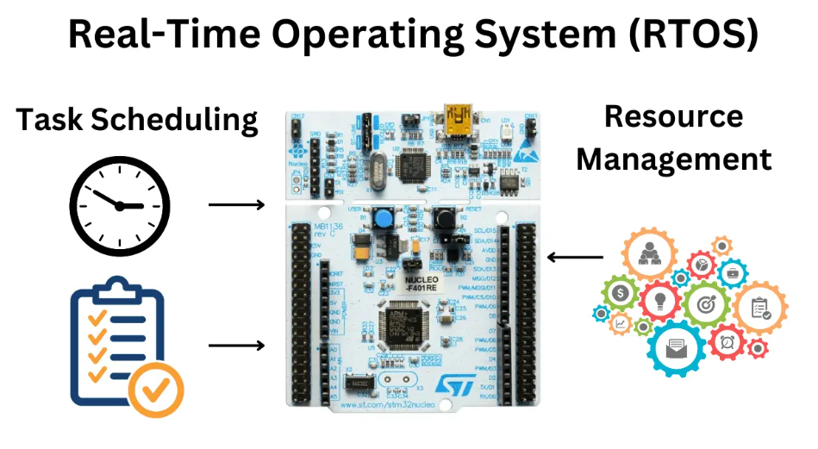

**How RTOS works?**

Let’s consider a real-world example to understand how an RTOS works. Imagine you have an autonomous robot that performs various tasks in a warehouse, such as picking up items and placing them in specific locations.

The robot’s tasks include:

* **Sensor Reading:** The robot needs to continuously read data from its sensors, such as distance sensors and cameras, to detect obstacles, recognize objects, and navigate the environment.
* **Path Planning:** Based on the sensor data, the robot needs to determine the optimal path to navigate through the warehouse, avoiding obstacles and reaching the desired locations efficiently.
* **Object Detection:** The robot needs to analyze the camera data to identify and classify objects in its surroundings, distinguishing between different items to be picked up or avoided.
* **Motion Control:** Once the path is planned and objects are detected, the robot needs to control its motors and actuators to move smoothly and precisely, following the planned trajectory and performing tasks like grasping objects.

In this scenario, an RTOS comes into play to manage the execution of these tasks efficiently and in a timely manner. Here’s how it works:

* **Task Scheduling:** The RTOS scheduler assigns priorities to each task based on their importance and time constraints. For example, the sensor reading task may have a higher priority to ensure real-time obstacle detection, while path planning can have a lower priority.
* **Context Switching:** The RTOS handles context switching, which means it can pause the execution of one task and switch to another task seamlessly. This allows the robot to respond quickly to changing situations and events.
* **Resource Management:**The RTOS manages the sharing of resources among tasks. For instance, if multiple tasks need to access the robot’s motors simultaneously, the RTOS ensures that they can do so without conflicts by implementing synchronization mechanisms like semaphores or mutexes. We will discuss semaphores and mutexes in the next tutorials.
* **Timeliness:** The RTOS guarantees that critical tasks are executed within their specified deadlines. For example, the motion control task needs to execute with precise timing to ensure the robot moves accurately and avoids collisions.

By utilizing an RTOS, the robot can effectively handle multiple tasks concurrently, respond to sensor inputs in real time, and achieve reliable and deterministic behavior. The RTOS ensures that each task receives the necessary processing time and resources to fulfill its requirements, ultimately enabling the smooth and efficient operation of the autonomous robot in the warehouse environment.

**Difference between super loop architecture and RTOS in Microcontroller**

When it comes to designing microcontroller-based systems, there are two common approaches for handling tasks and resources: super loop architecture and Real-Time Operating System (RTOS). Both have their advantages and drawbacks, and the choice between them depends on the specific application requirements and constraints.

Super loop architecture, also known as the main loop architecture, is a simple and straightforward approach for handling tasks in microcontroller-based systems. In this architecture, the main program loop repeatedly executes a sequence of tasks, each of which takes a fixed amount of time to complete. The tasks are scheduled sequentially, and the order of execution is typically determined by the order in which they appear in the main loop.

RTOS, on the other hand, is a more advanced and flexible approach for handling tasks and resources in microcontroller-based systems. In RTOS, the tasks are managed by a kernel, which is responsible for scheduling, context switching, and resource allocation. Each task has its own priority and execution time, and the kernel ensures that high-priority tasks are executed before low-priority ones.

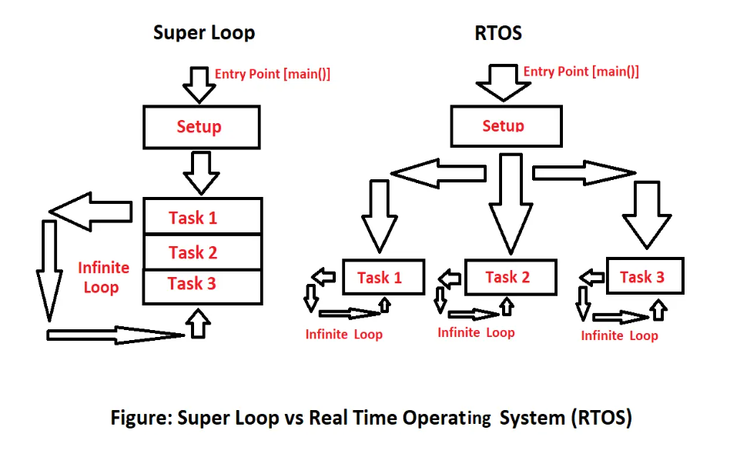

**What is FreeRTOS?**

FreeRTOS, which stands for Free Real-Time Operating System, is an open-source real-time operating system kernel designed specifically for embedded systems. It provides a compact and efficient solution for running multiple tasks concurrently while meeting strict timing requirements.

Developed by Richard Barry in 2003, FreeRTOS offers a preemptive multitasking environment, where tasks are scheduled and executed based on their priorities. It allows developers to break down complex applications into smaller tasks, each with its own priority and execution requirements.

FreeRTOS supports a wide range of microcontrollers and microprocessors, including the popular STM32 family. It offers features such as task management, inter-task communication, synchronization mechanisms, timers, and memory management.

Tasks in FreeRTOS are created and managed using APIs provided by the kernel. Each task has its own stack and can perform specific operations independently. The kernel scheduler determines which task should run based on their priorities and any synchronization or timing constraints.

FreeRTOS also provides synchronization mechanisms like semaphores, mutexes, and queues, which allow tasks to communicate and share resources safely. This ensures coordinated execution and avoids conflicts between tasks.

One of the key advantages of FreeRTOS is its small footprint. It has a minimal memory overhead, making it suitable for resource-constrained embedded systems. Additionally, it is well-documented, actively maintained, and has a large user community, providing ample resources and support for developers.

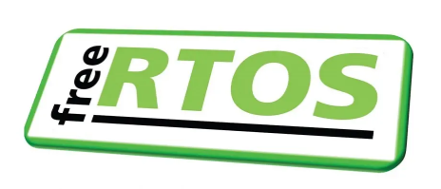

To read more about FreeRTOS, you can visit their official [website](https://www.freertos.org/).